

TSO/ISPF ASSESSMENT 5/7/2024

1. Create 5 Partitioned Sequential (PS) and 5 PDS with different names.

* Creating 5 PDS: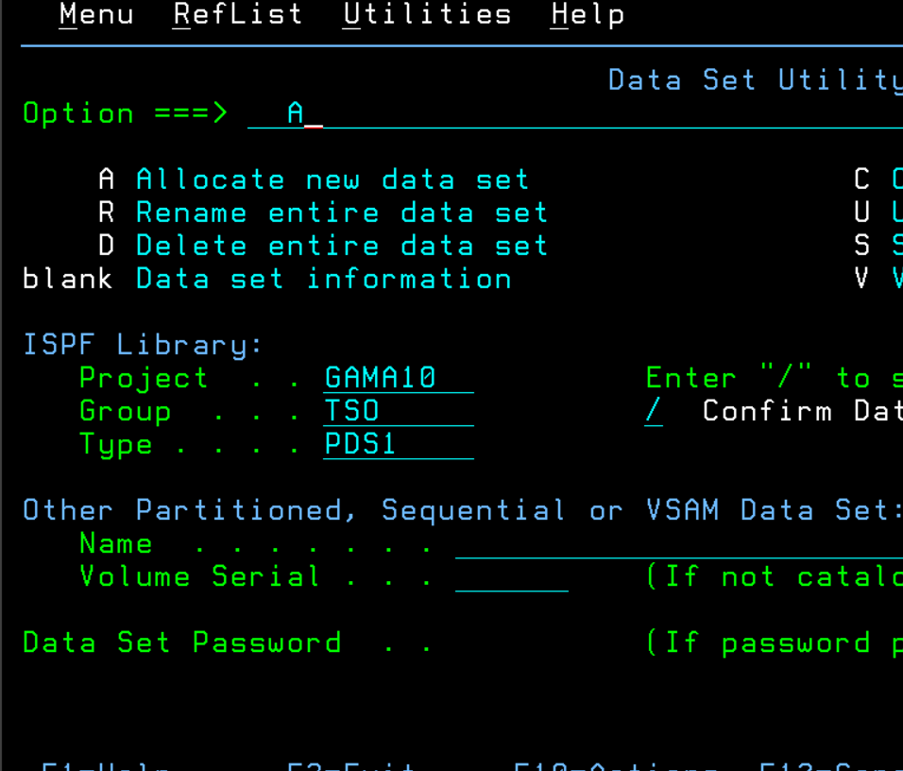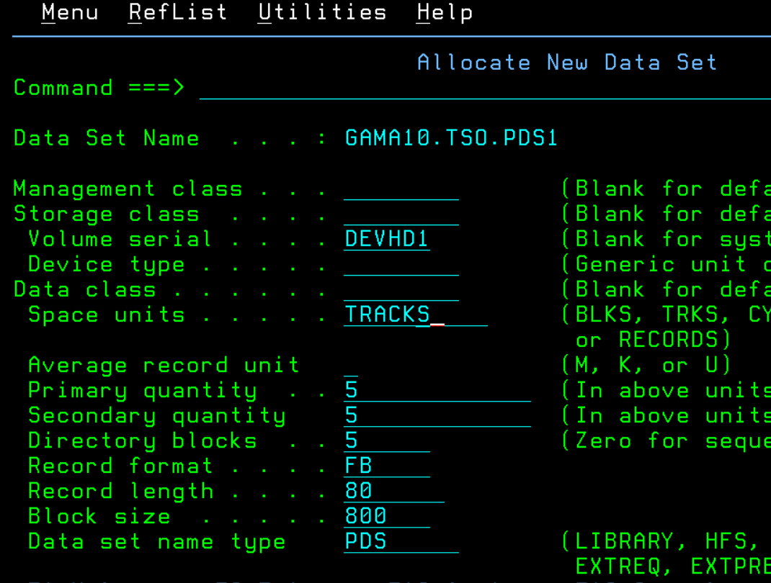
* Creating 5 PS: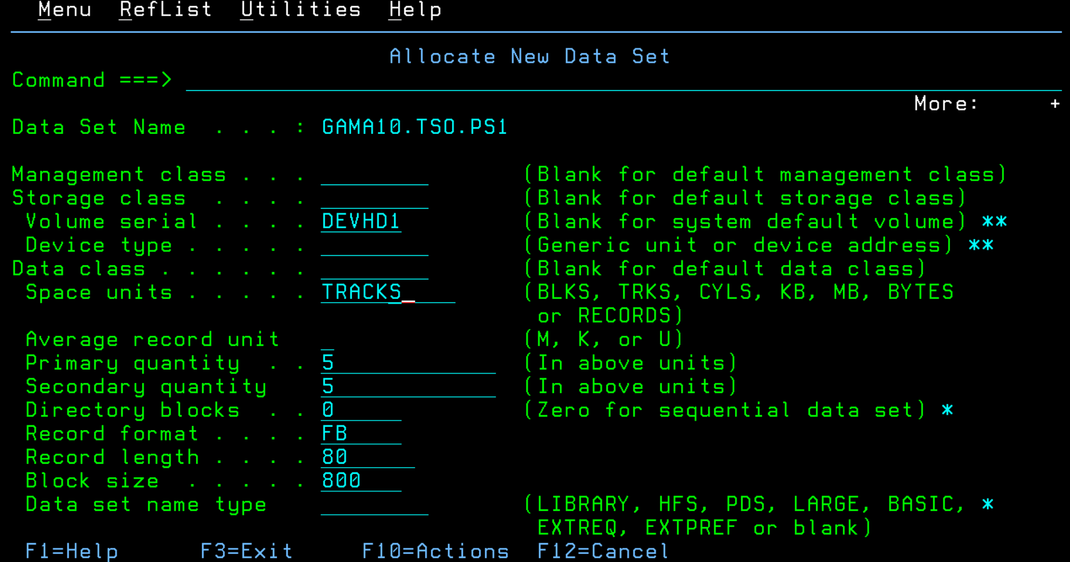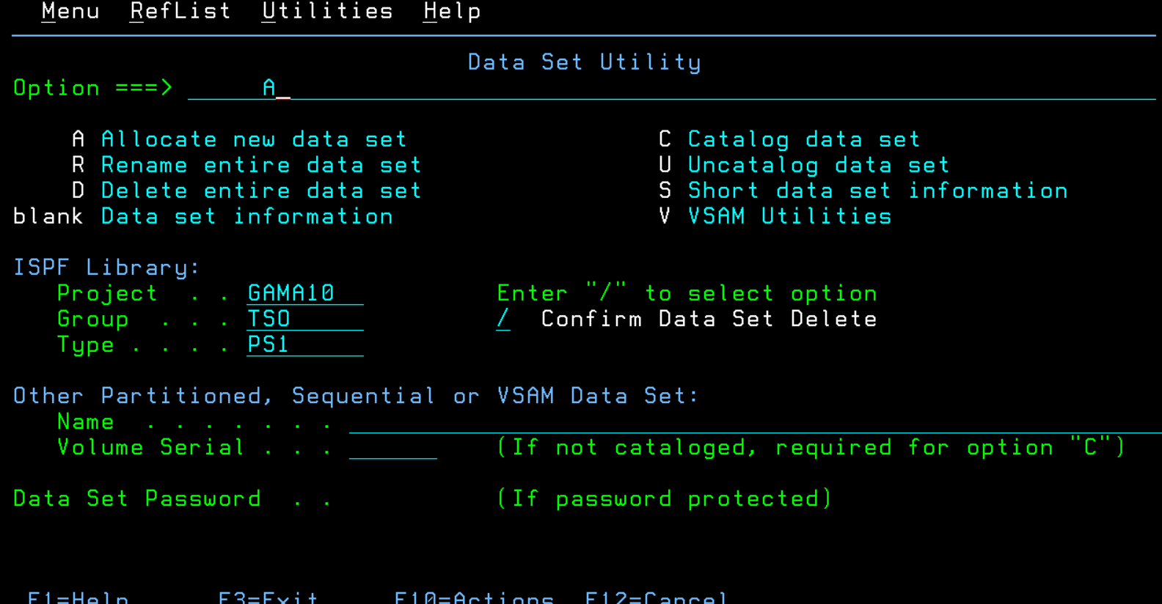
* DS List: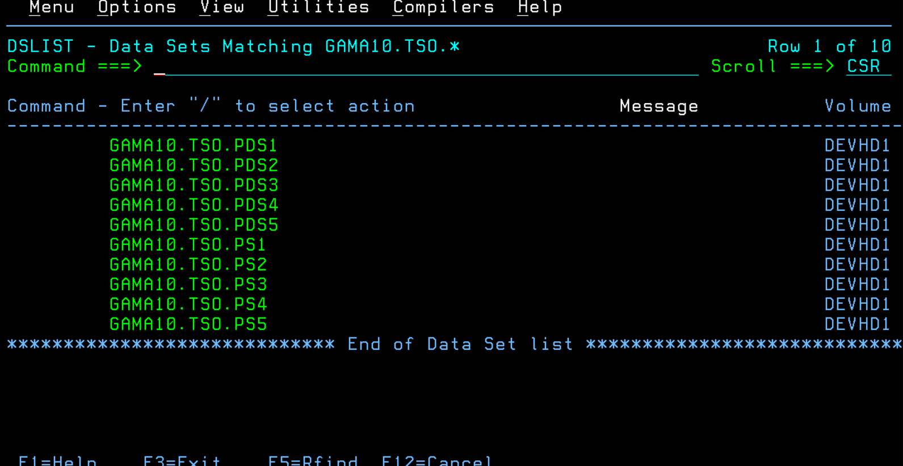

1. Example: userid.tso. source1, source2…. similarly, userid.tso. pds1, pds2 … using Line

commands insert enter data into the PS and PDS members.

* Inserting PS data files into PDS members.

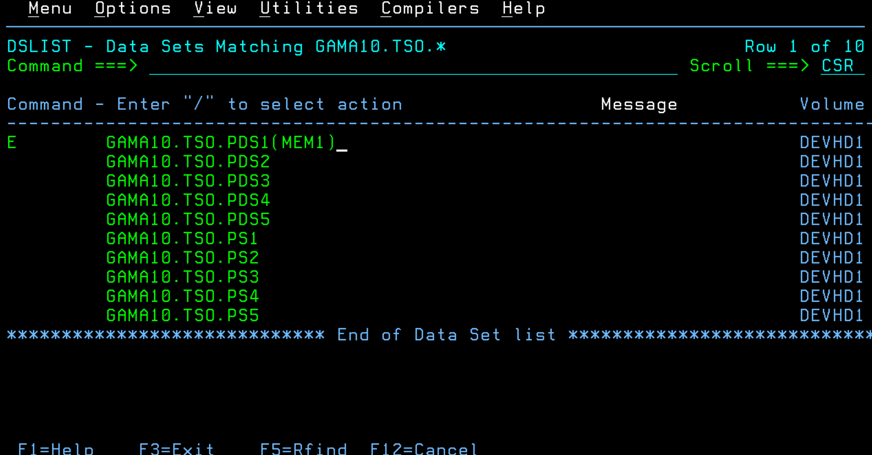

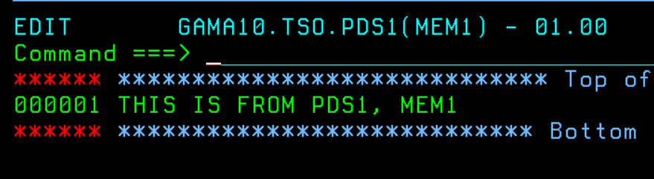

* Inserting data files into PS members. I used e (edit), i (insert) and r (repeat).

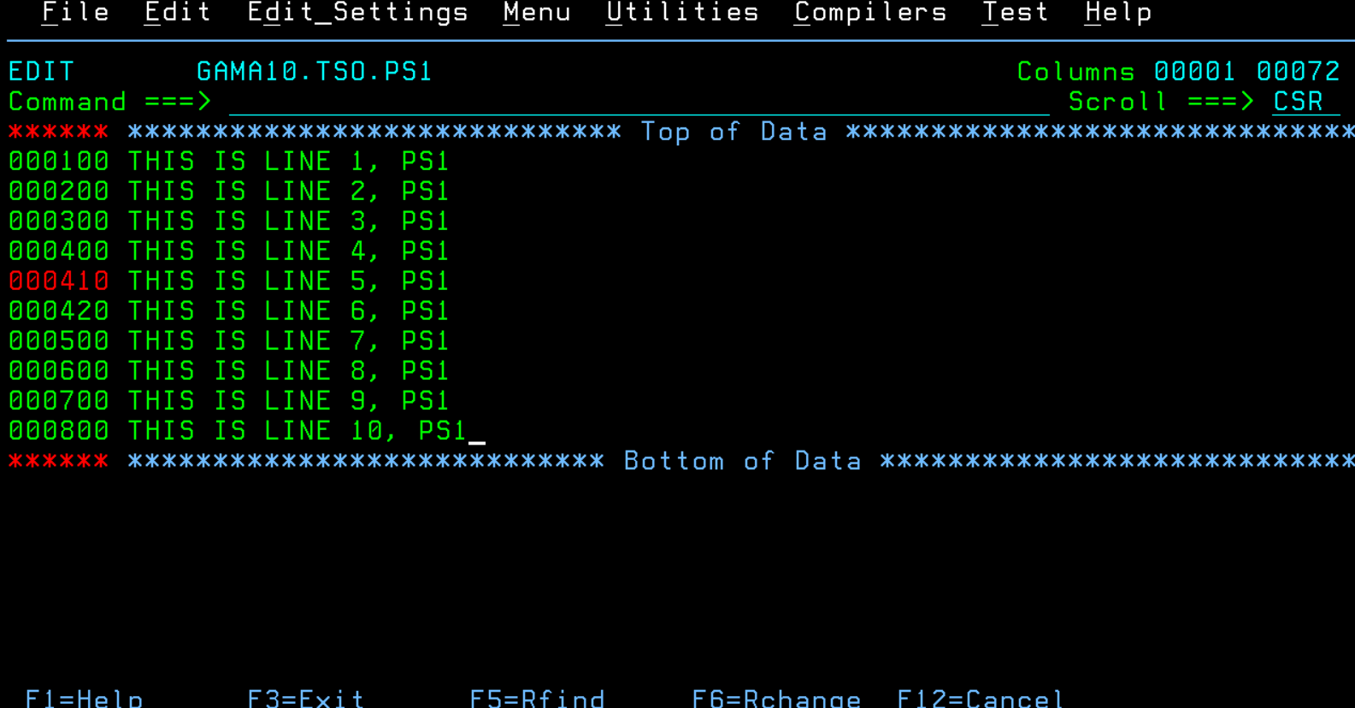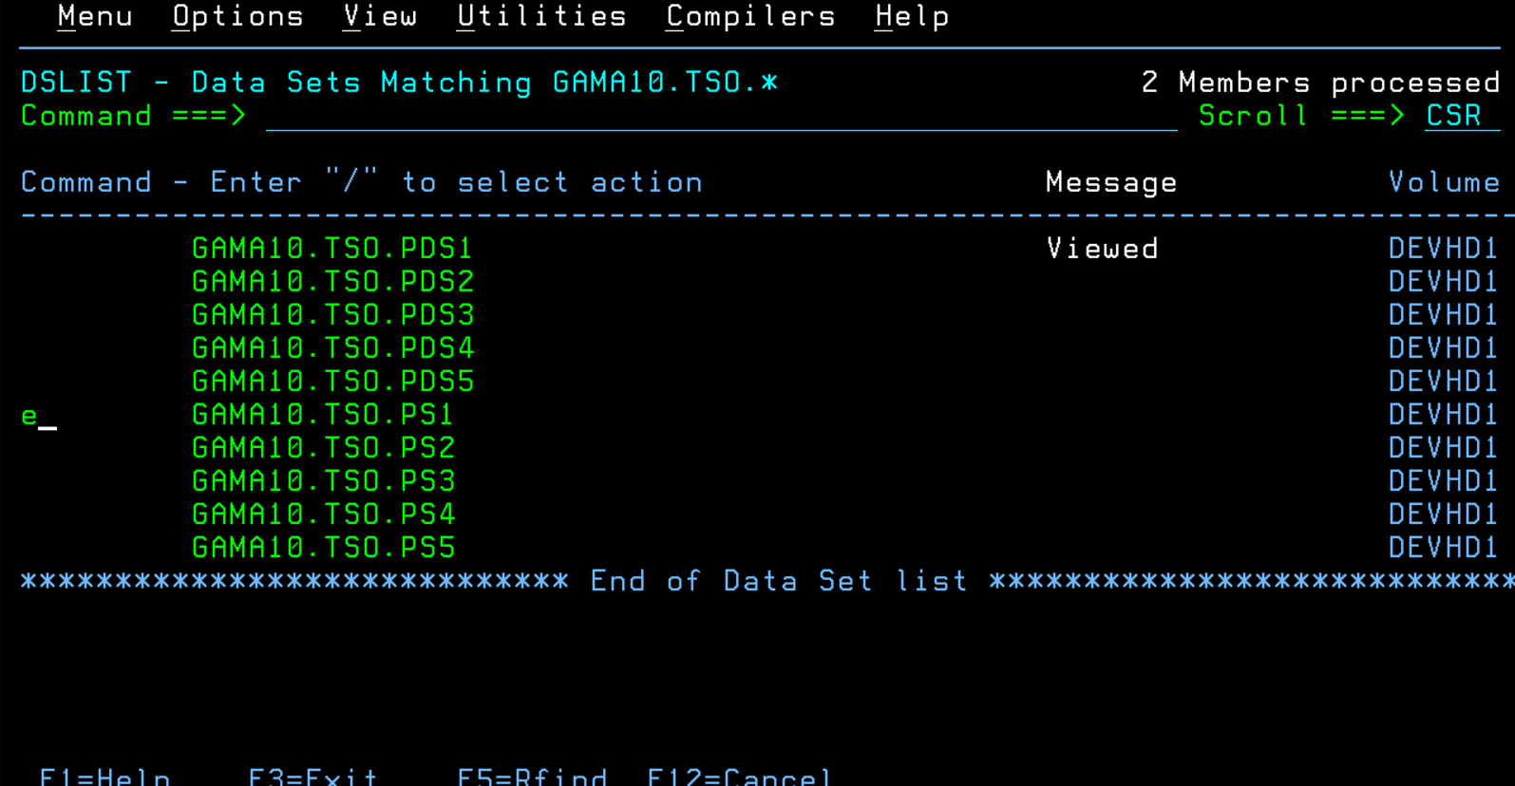

1. Try move first 10 lines from ps1 to another ps2, copy last 10 lines of ps1 and paste it after the first 10 lines (i.e. append) the data.

* Cut for copy and cc for the block of only the last 10 lines (can also use c10 for copy). Then used paste with destination a in ps2.

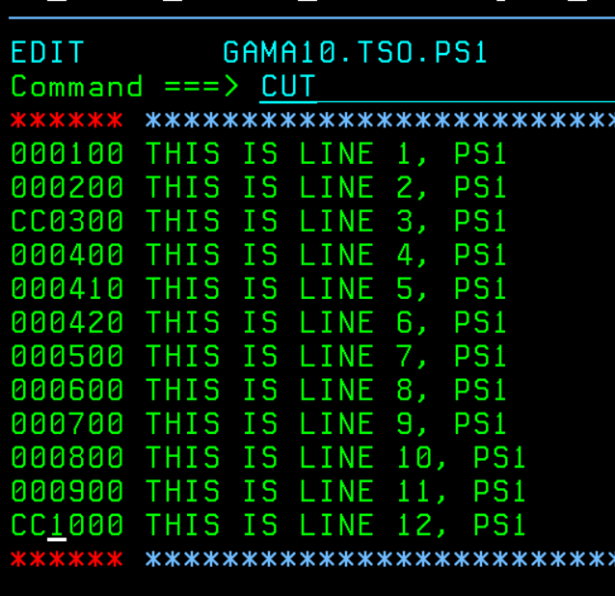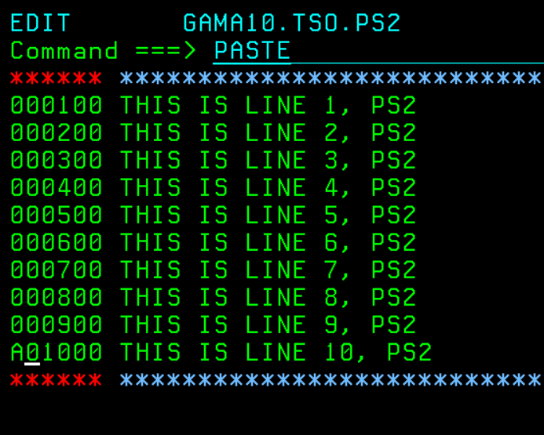

1. Try browse / view options to view the contents of the PS and PDS members

* Using v for PDS1 to show members files.

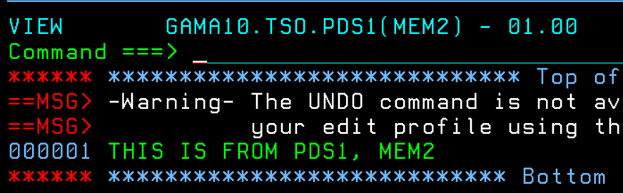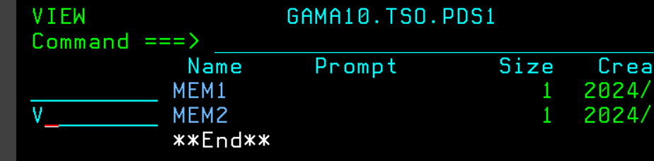

* Using b for PS2 to show file contents.

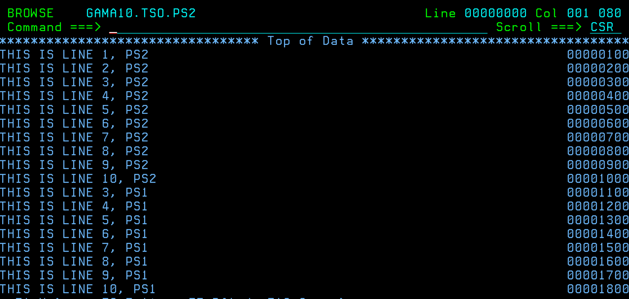

1. Copy all the contents of PS without using CC command to another PS and paste it.

* Using just the cut command we can copy all the lines in the PS file. Then paste it into another PS with paste command.

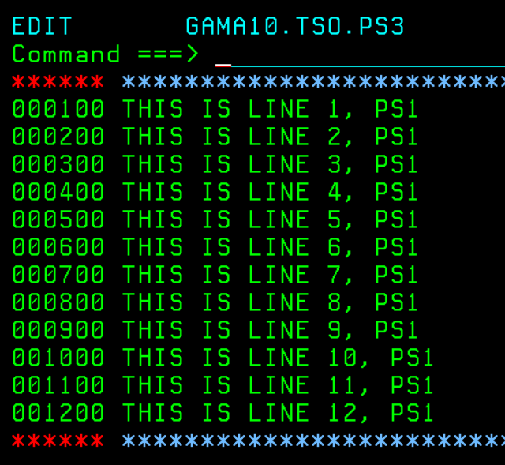

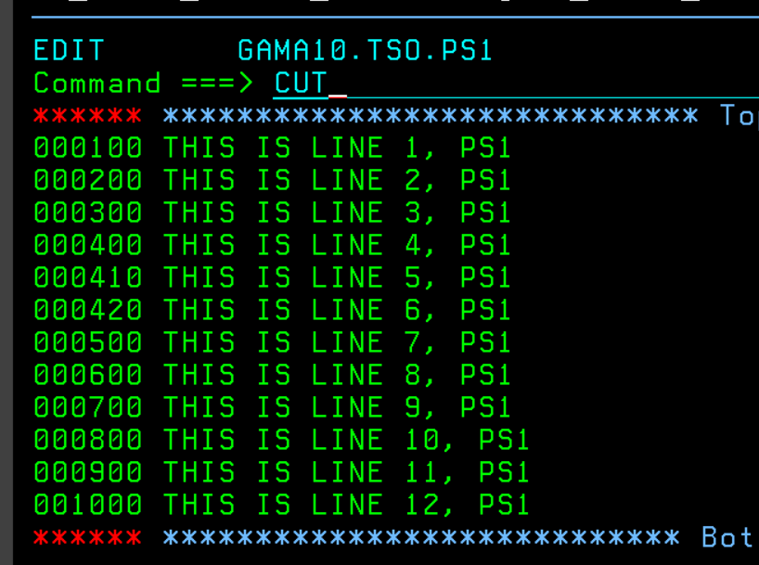

1. Find for particular string in your PS and explain with boundaries defined.

* Used the find command to find ‘TXT’. The boundaries mean the columns so for ‘find txt 0 5’ it means 0-5 columns and won’t be found because txt is in 12-14 columns. So, the command ‘find txt 12 14’ or ‘find txt 0 15’ will find txt.

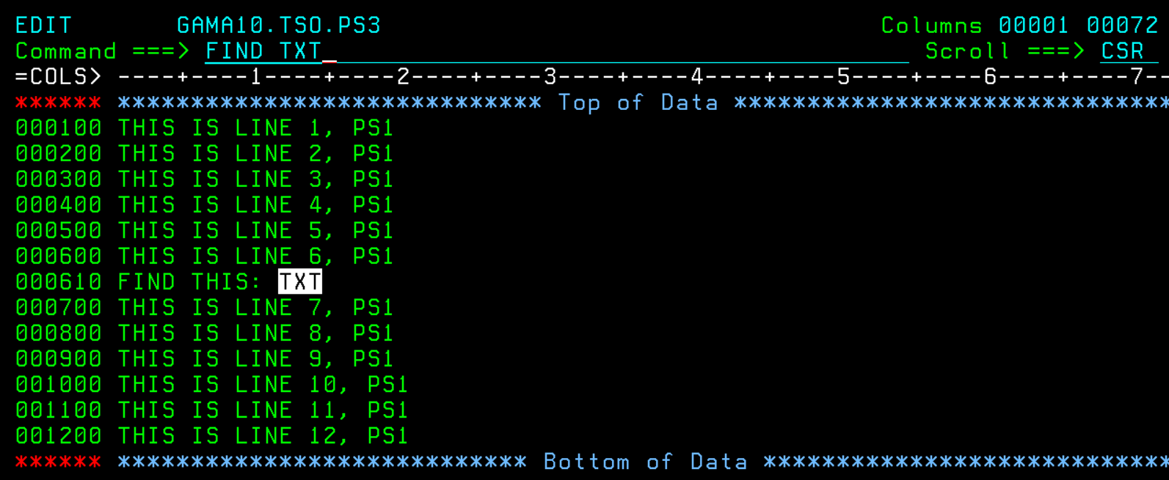

1. Try to use the UNDO command and explain when undo cannot be performed.

* The UNDO command is not available in z/OS ISPF because ISPF doesn't have a built-in undo feature like modern text editors. This environment was designed without such functionality.



1. Create two dataset list (DSLIST). Give name as “BANK” one for listing all banking files. For example, it has to list userid.bank.* and second one give name as “INSUR” which is to list userid.insur.*.

* Created PDS datasets using 3.2 and searched for them in user catalog in 3.4.

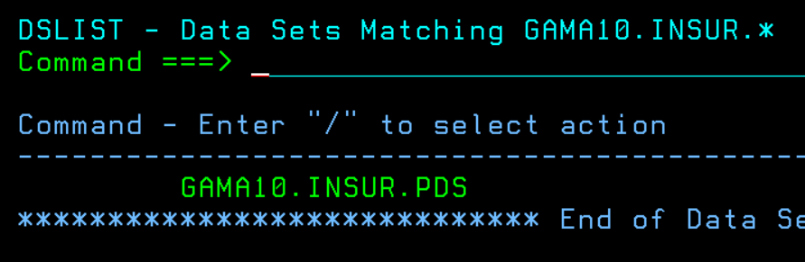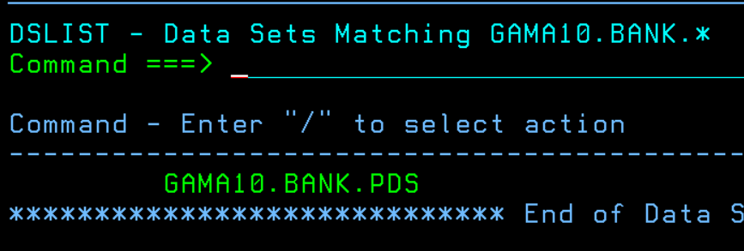

1. Save the members of PDS and characteristics about the PDs in separate PS.

* Bank PS members: deposits/transactions and bank statements.
* Insurance PS members: claims and investments / bonds.

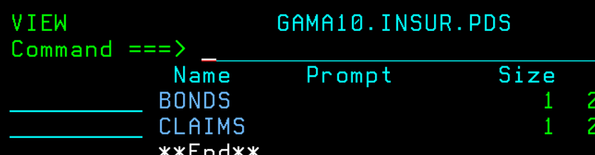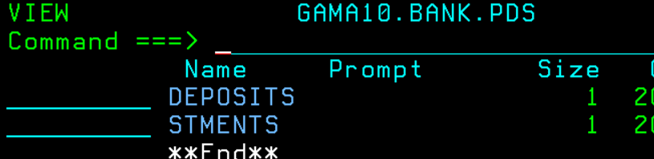

1. Check whether one member (for example: ABC) is present in any PDS and it has to list what are the PDS that contains ABC.

* This took some time as I was trying to compare options and kept failing. In the end, I tried to think about simple stuff and typed help in DS List command line and saw the member command.

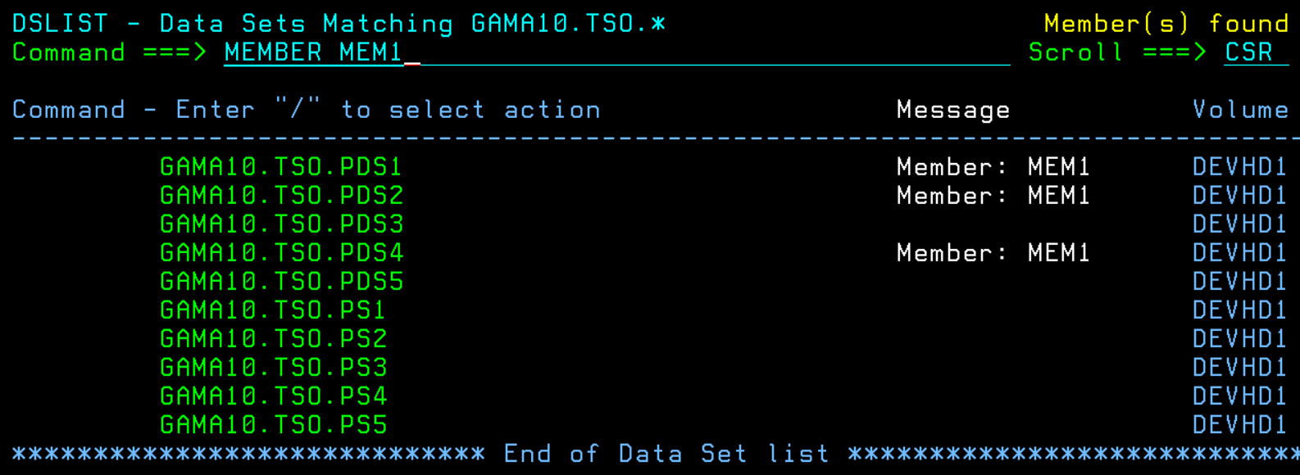

1. Sort the contents of PS “Userid.welcome.ps”

* Sorting lines in a ps file with unnum command.

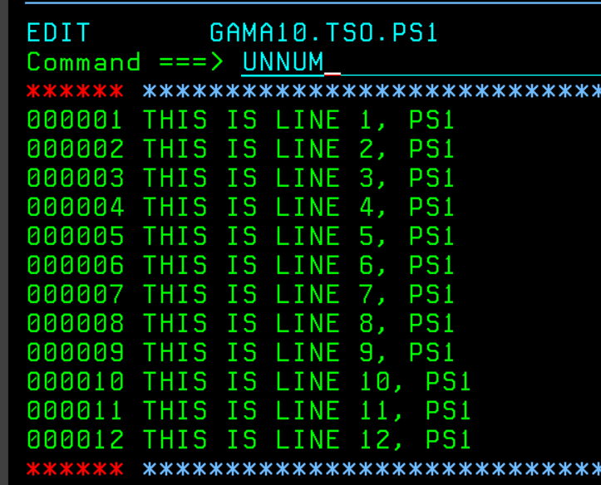

1. Try to allocate a dataset existing and note down the error faced.

* You get this error called ‘Duplicate data set name’.

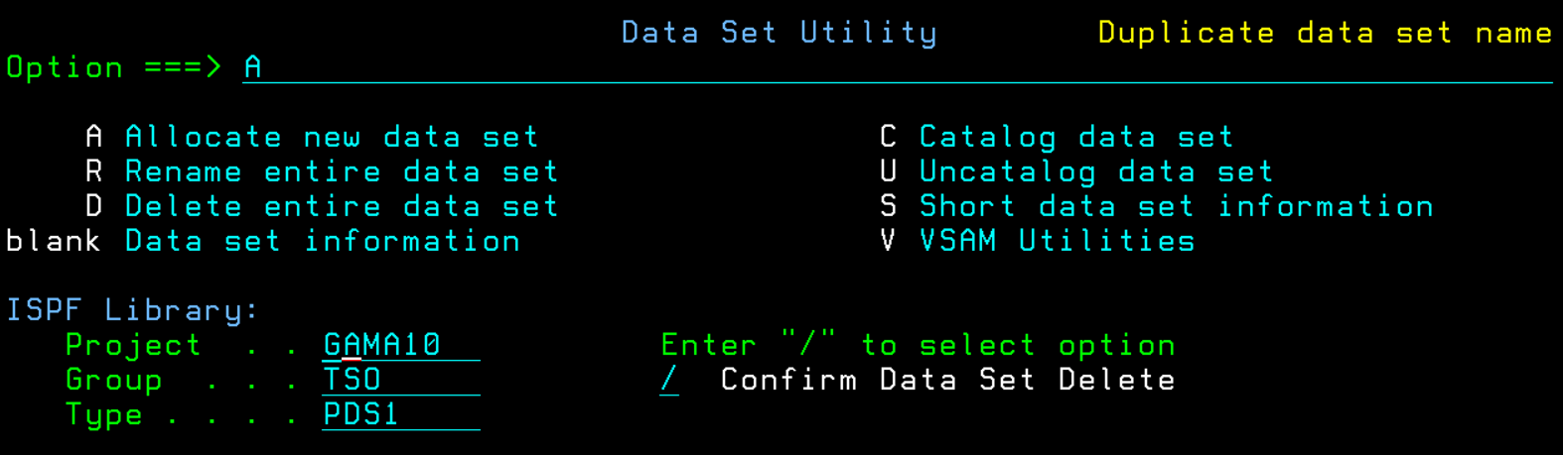

1. List only the files with second qualifier starting with **A**. For example,

userid.a.ps,

userid.abc.ps,

userid.a1.ps

* Went to 3.4 then I searched userid.a*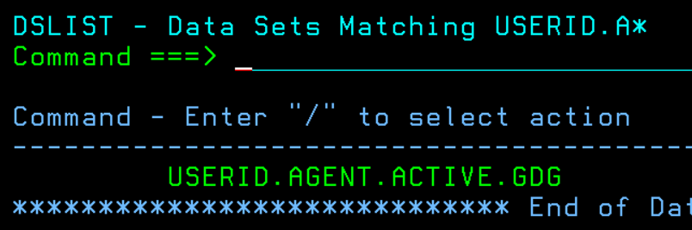

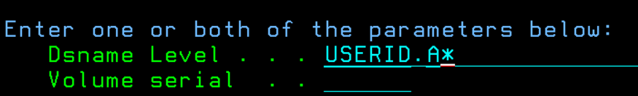

1. Rename the PS as **userid.welcome.ps** and type your bio data and your friend’s data in your welcome PS. NOTE: your data must be in horizontal manner not in vertical manner.

* R for rename, then I wrote the bio data.

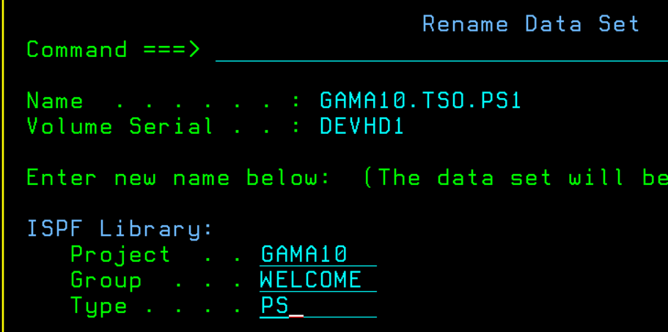

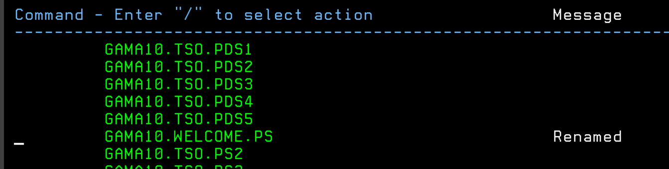

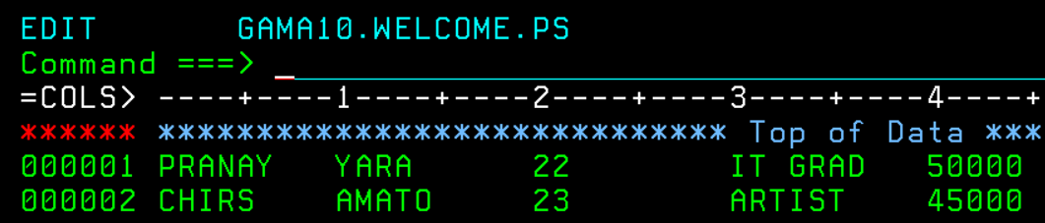

1. View the information about the PS and PDS.

* Used i for ps information and s for pds information in DS List.

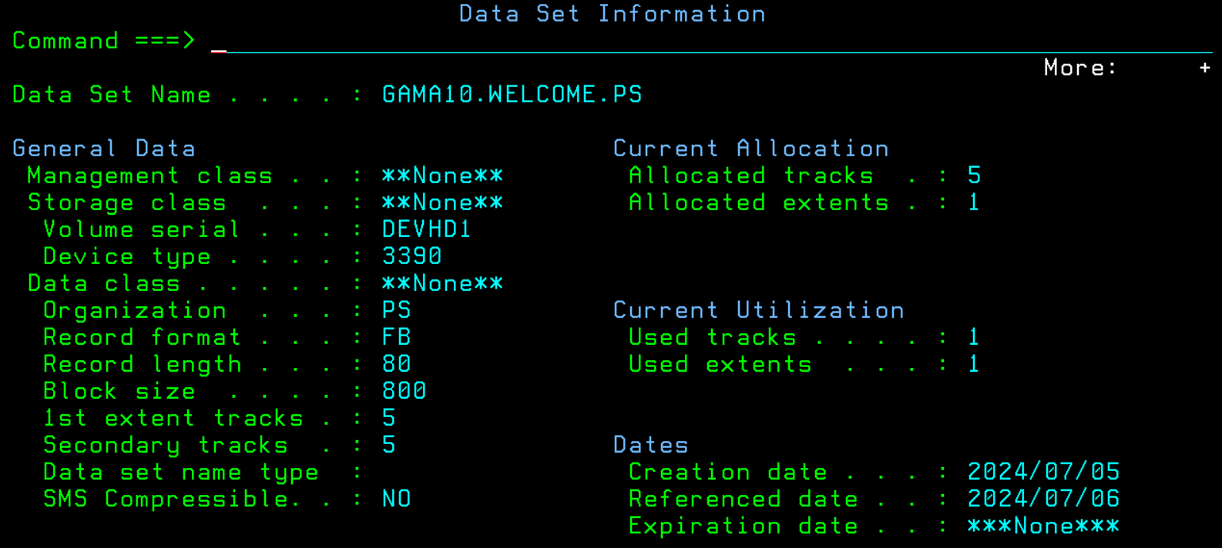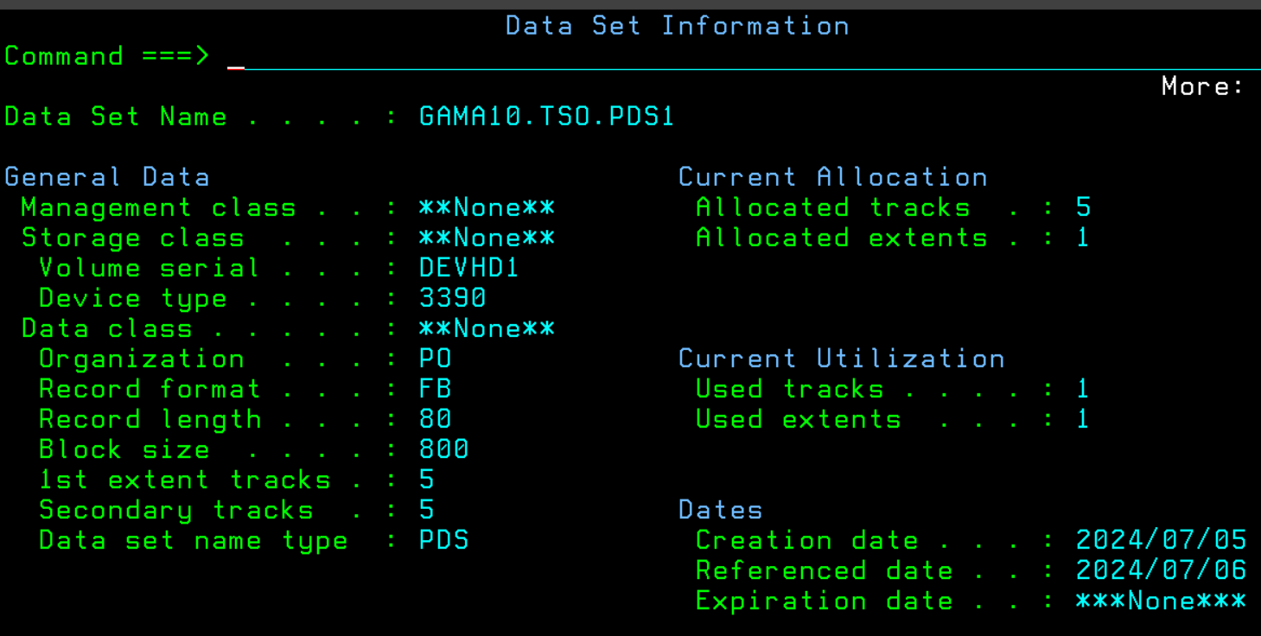

1. Rename the member of the PDS.

* I went into the PDS and then used R in the interactive line.

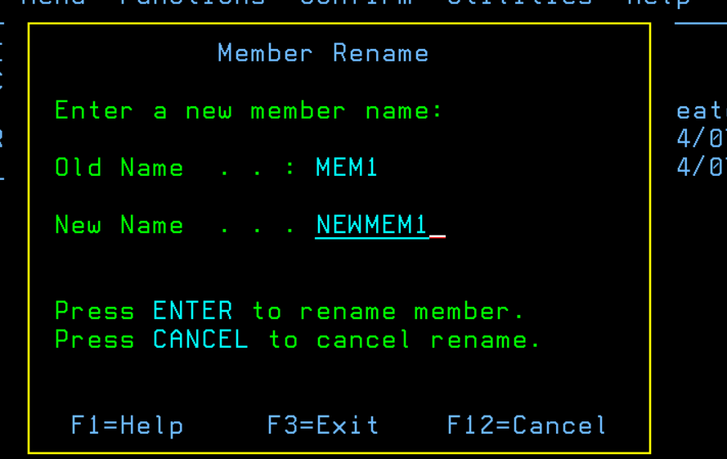

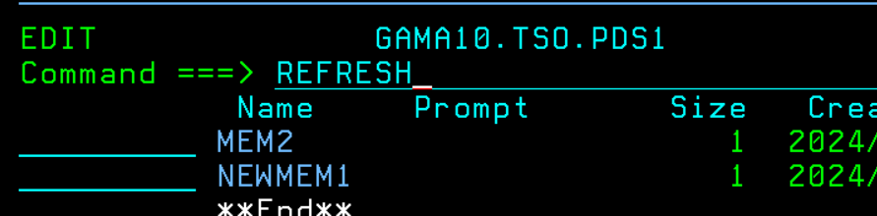

1. Use SUPERC and SUPERCE commands and SEARCH and SEARCHFOR- extended options.

* First: using SUPERC, compared gama10.tso.pds1 (new) with gama10.tso.pds2 (old).

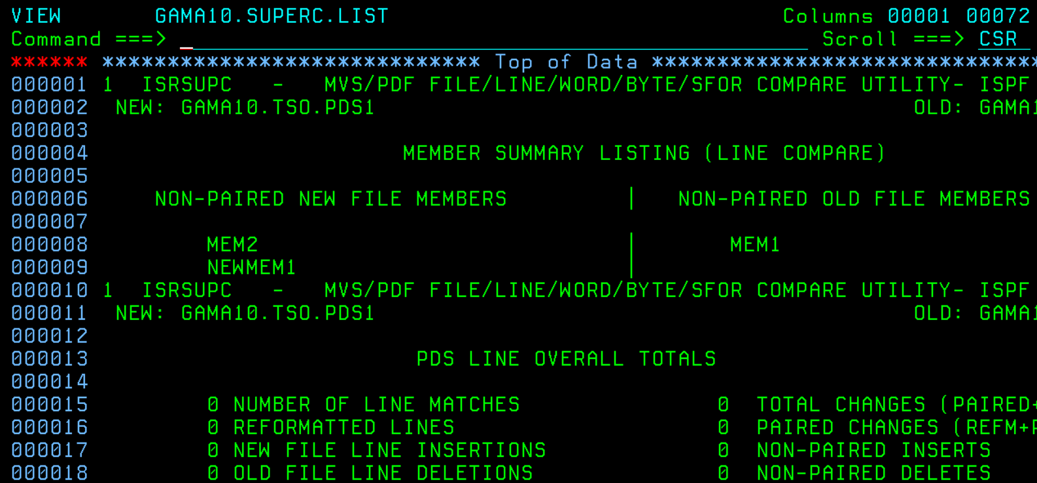

* Second: using SUPERCE, compared gama10.tso.pds1 (new) with gama10.tso.pds2 (old) - gave me the same output as SUPERC.

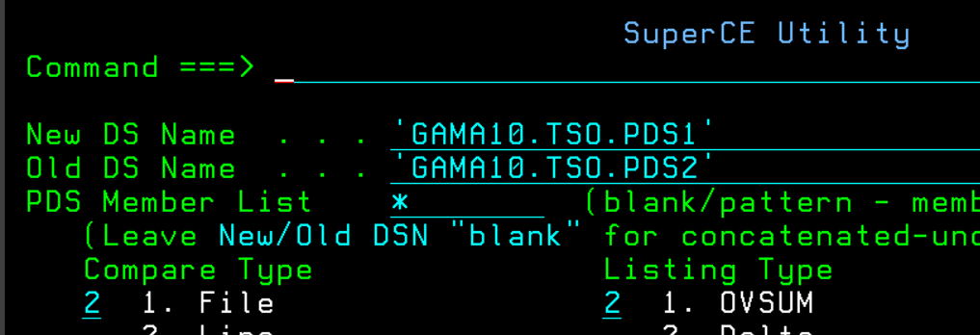

* Third: using SEARCH, searched ‘THIS’ in all gama10.tso.pds1 members.  
    
  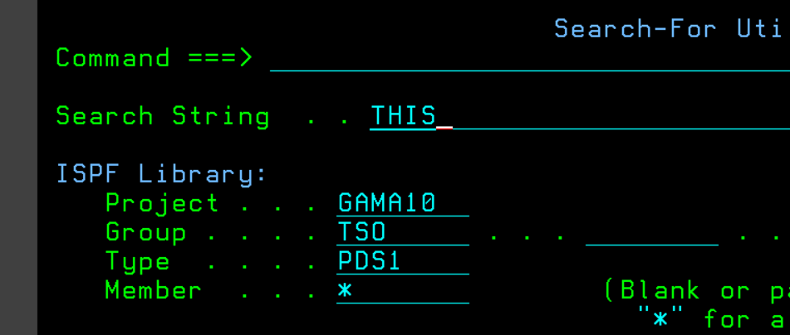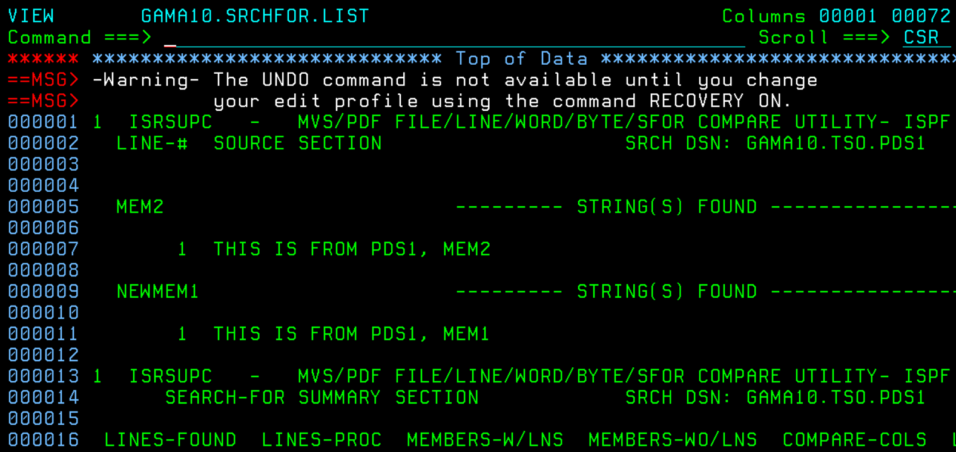
* Fourth: using SEARCHFOR- extended, searched ‘PDS1’ in all gama10.tso.pds1 members.  
  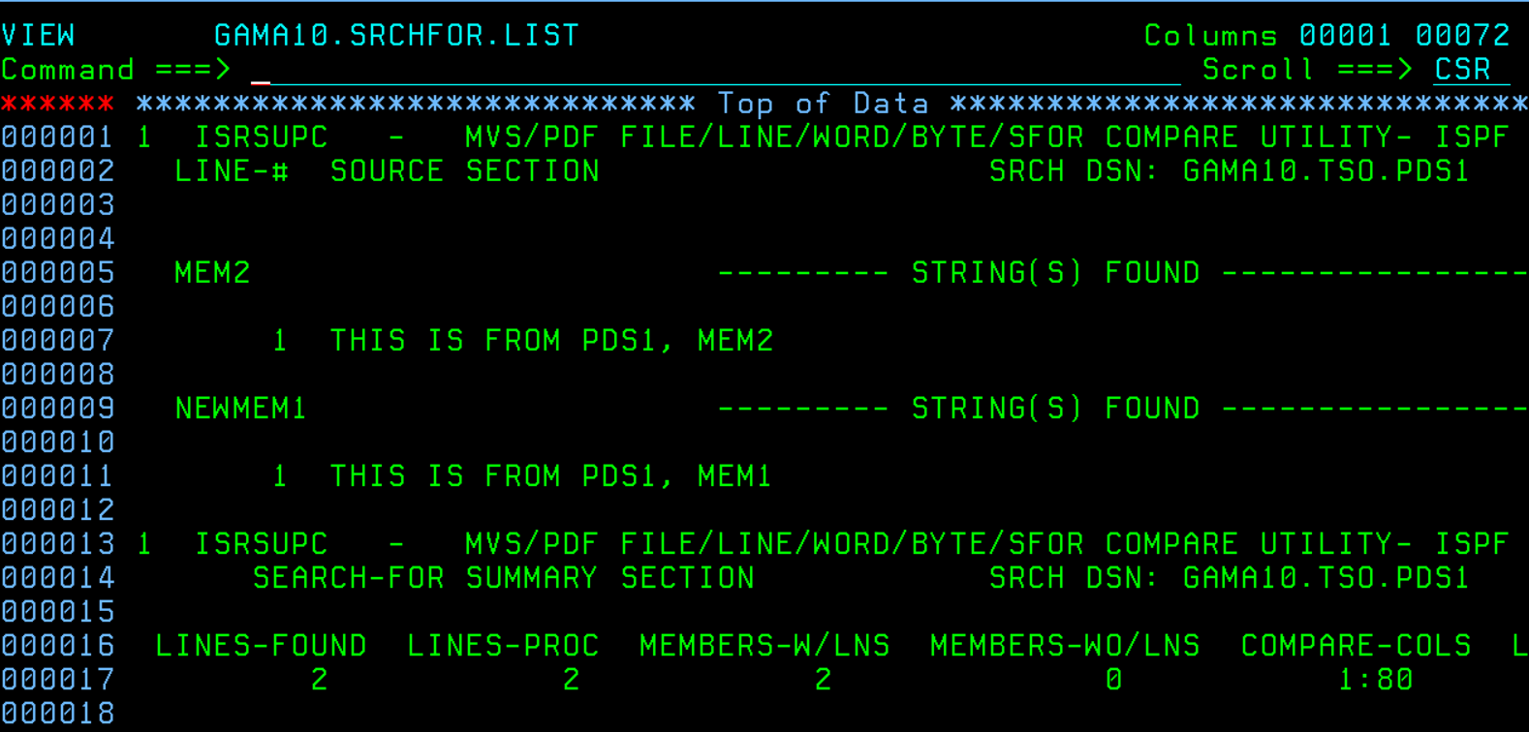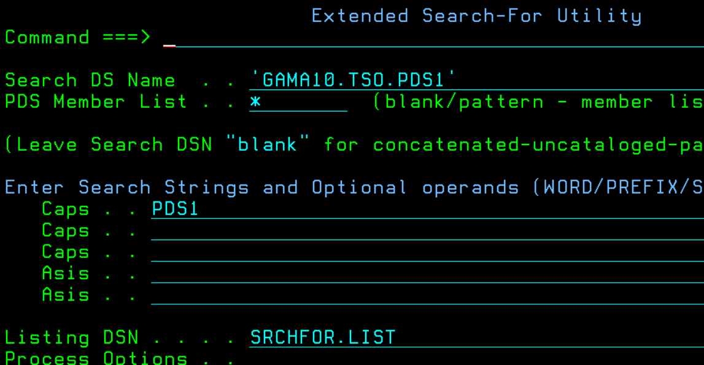

1. What are the ways one can compress the datasets?

You can compress datasets with option c or z.

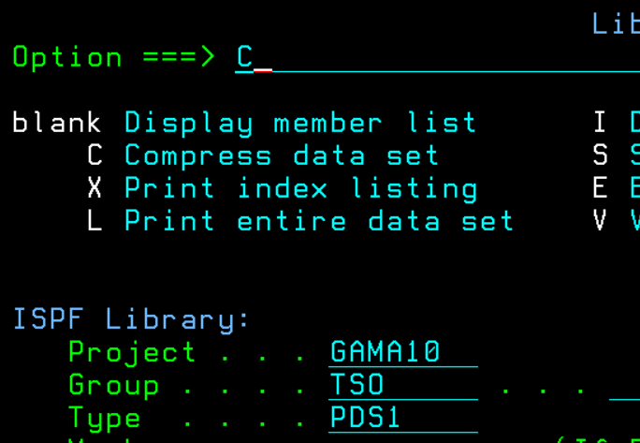

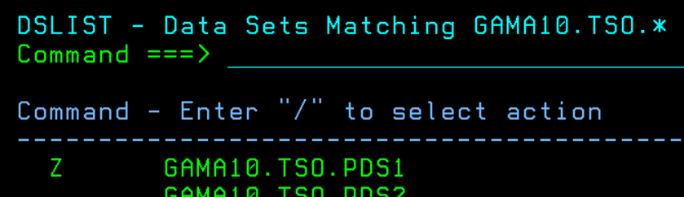

1. Using 3.3 option copy all members from one pds to another, likewise copy only selected members.

* Went to 3.3, filled the correct fields to copy all members from pds1 to pds3.

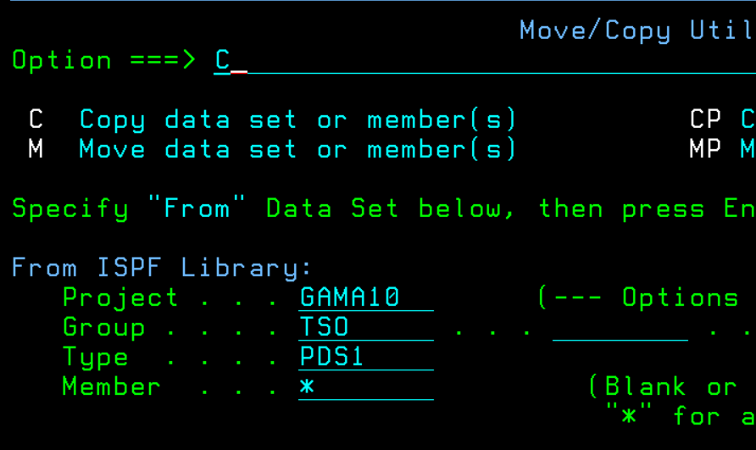

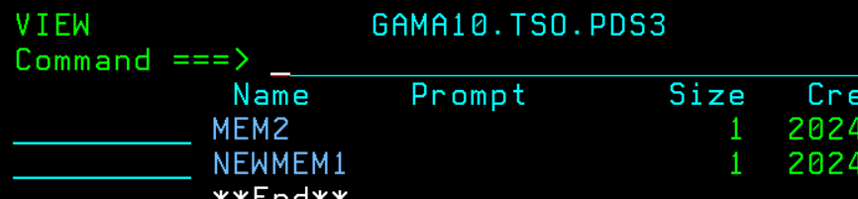

* Then I copied only newmem1 from pds1 to pds5.

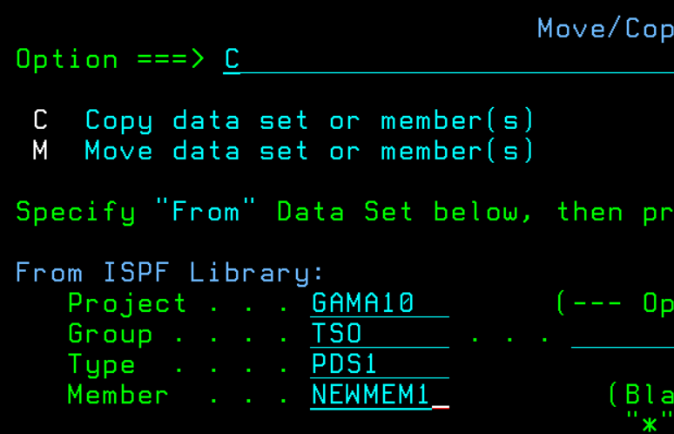

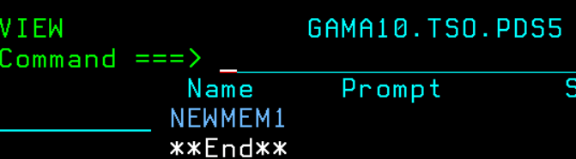

1. Using 3.3 try to copy a specific member from one PDS to another PDS. The member should be already existing in the TO PDS.

* I used the existing newmem1 file in pds5 that I copied from pds1 in the previous question. When I tried to copy it again, it gave an error saying newmem1 not replaced, if I really wanted I could replace it by selecting the option. I noticed you can only copy a file once into a pds after that you can only replace it.

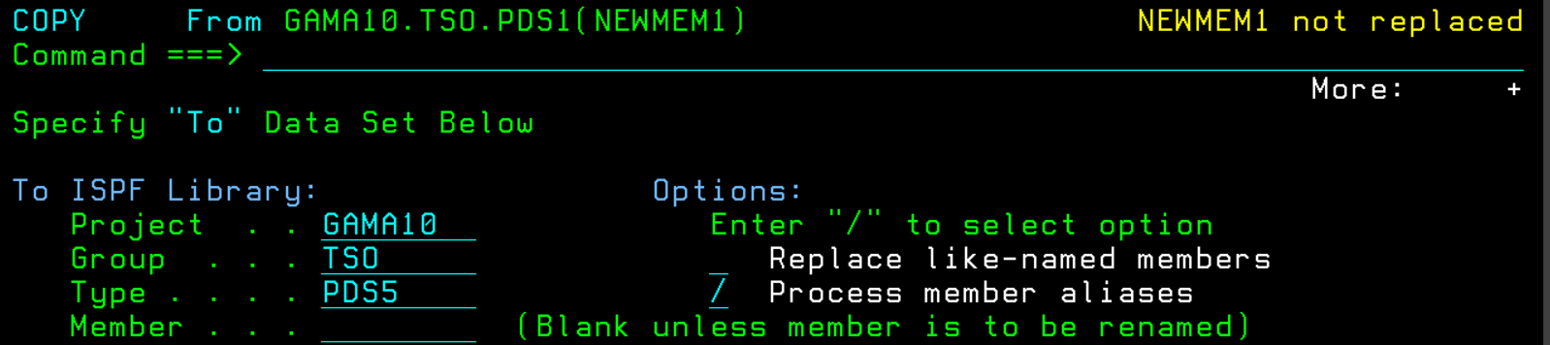

1. How to use locate command?

* Used 3.4 and searched datasets. Then view pds1, used locate command followed by a name to find datasets. Here I used locate newmem1.

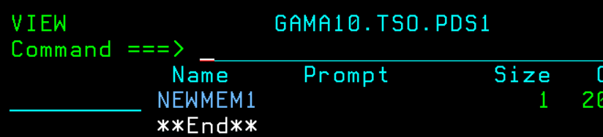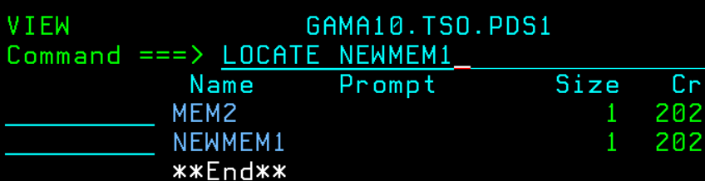

1. Open a PDS which consists of 5 members. Delete all the members in a single *command line* command.

* Opened pds, then used a TSO delete command and it worked.

